How to organise myself

What I need:

What do I need to do first?

What do I need to do next?

How much time do I My reward for completing the task.
get to do the task?
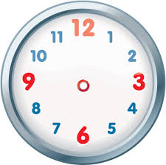

Becoming independent is a big part of your child achieving tasks and activities.
For some children, learning this naturally can be difficult.
This organisation visual can help them to see what is needed.
If possible, print and laminate it. Use a whiteboard marker so you can rub out and re-use for other tasks.
If not, draw a similar one on paper each time.
Eventually, your child will learn to be independent in this way.

