Making a good choice
People will be pleased with me.

If I choose to…

I will feel proud of myself. I will feel happier.

Because I have done my task straight away, I may have time to do something I like.

If I choose NOT to…
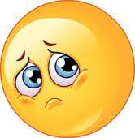
I will feel really upset with myself.
The adults will be grumpy.
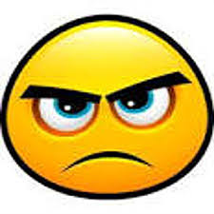
There will be consequences
X

