The Coronavirus Mask
I am 4 years old.
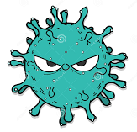
I did not really understand what the coronavirus was, or why I didn’t have to go to school for a long time.
Mummy told me we had to stay at home because
the Coronavirus makes people very poorly.

When we go out for our walk or bike ride once a day, I saw people wearing masks.
It frightened me because in my stories the Baddies all wear masks.

Mummy told me the masks were to help keep the germs away from our faces.
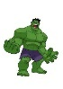
She made me my own mask out of my old pyjamas – it has got the Hulk on it! I love it!

I wear it all the time, and now I don’t feel scared of people wearing their masks.
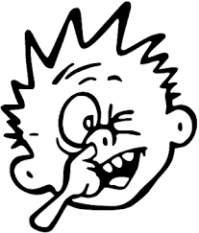
Mummy calls it my ‘Don’t Pick Your Nose Mask’.
I love picking my nose. It feels so good.
But that is a sure way of spreading the
Coronavirus germs. My mask helps me to stop
picking my nose now.

So, if people wear their masks, they won’t pick their noses, and soon the Coronavirus will leave us alone.

