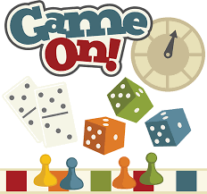
Playing a Game
I like to play board games, but I do not like losing.
Nobody likes to lose.

So –
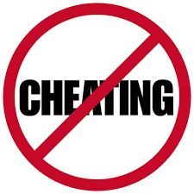
I could cheat.
But if I do, nobody will want to play with me.
Then I won’t ever stand a chance of winning.

If I play to the rules, I could also come second

win

If I give up or get angry, I don’t stand a chance of anything and I will feel upset.

So I will try to have fun playing, and you never know, I might even win!

